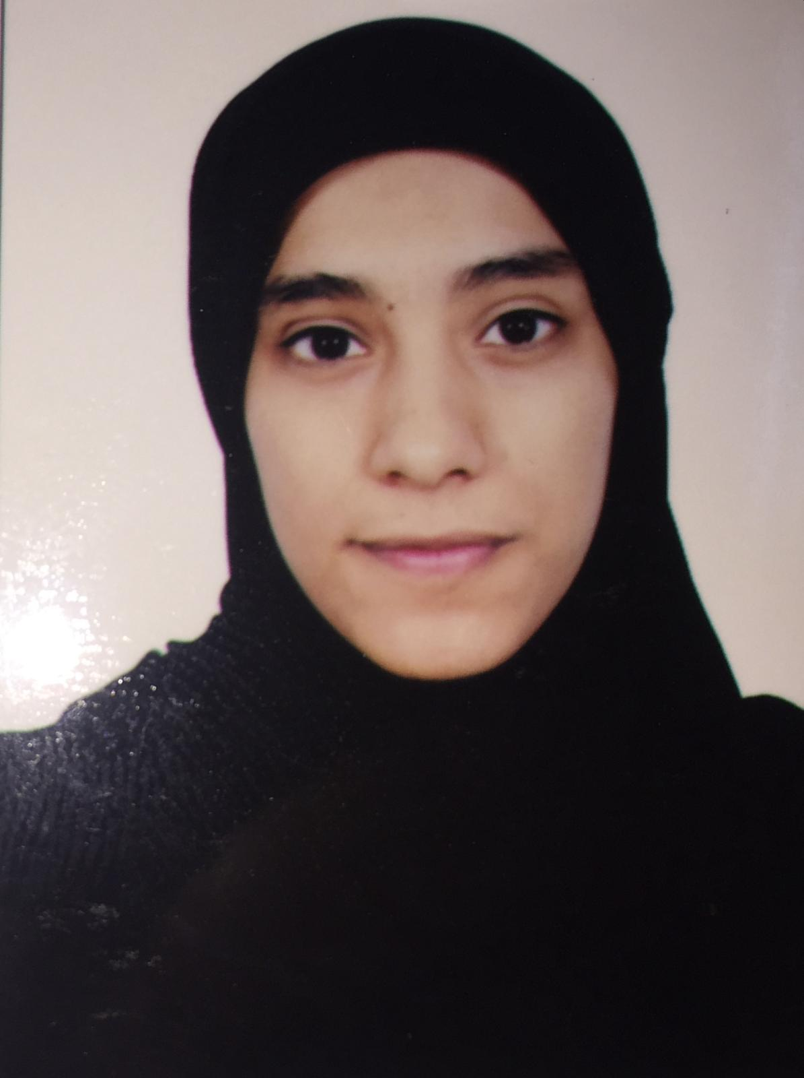
Name: Zahraa Muslem Juma Habib
Address: House-1359, Road-3336, bloack- 1033 AL ALMalkiya
Date: 20/10/2018

To Whom It May Concern:

I am writing to apply for any position in your hospital. I am confident that I would make an outstanding addition to your team.

As you can see from my attached CV, I am a highly motivated learner, I consider my greatest strengths to be my ability to develop and maintain excellent working relations with others.
I believe that working in a challenging environment such as yours will provide an excellent opportunity for me to best utilize my skills.
I hope that you will consider my application and I would welcome to receive a phone call/e-mail so that we might be able to set up an interview. If you need any further information then please do not hesitate to contact me.
Thank you for your time and I look forward to hearing from you.
Yours faithfully,
Zahraa Muslem
991007778

Curriculum Vitae

Personal details:
Name: Zahraa Muslem Juma Habib

Date of Birth: 22 - 10 - 1999 CPR Number: 991007778
Nationality: Bahraini Languages: English and Arabic
Address: House-1359, Road-3336, bloack- 1033 AL ALMalkiya

Mobile Number: 335360976 Related Number: 33244457
E-mail: zahoora2210z@gmail.com

Career Objective:
A highly motivated and enthusiastic student. Seeking a challenge and expansion of my role where I can use my maturity, skills and experience to make a valuable contribution in any position. Although I am special need student which I has hearing impairment (wearing hearing aids) but I think I can do it .

Professional Qualifications:

Graduated from : Hamad Town secondary school
GPA: 68,6.9%

Graduation date: 22-6-2017

Additional Information:

1-Computer skills:
Able to accurately work on computer (Competent with a range of computer skills)

.
2-Hobbies:
- Reading
- Sports

